

Operating System
Lab #7 Operator Overloading

SUBMITTED BY:
UBAID AHMAD
ROLL NO:
2410-0011
SUBMITTED TO:
Ma’am Laiba Tanveer
DATE:
04/11/2025
Task 1
Code:
#include <iostream>
using namespace std;
class Rectangle{
int length;
int width;
double area;
public:
Rectangle(){
length=0;
width=0;
}
Rectangle(int l,int w){
length=l;
width=w;
}
double Area(){
area=length*width;
return area;
}
double Area(int l,int w){
length=l;
width=w;
area=length*width;
return area;
}
bool operator==(Rectangle &r){
return (area==r.area);
}
};
int main(){
Rectangle r1(4,5);
double area1=r1.Area();
cout<<"Area of First rectangle is: "<<area1<<endl;
Rectangle r2;
double area2=r2.Area(7,9);
cout<<"Area of Second rectangle is: "<<area2<<endl;

if(r1==r2){
cout<<"Area of rectangle 1 is equals to area of rectangle 2!"<<endl;
}else{
cout<<"Area of rectangle 1 is not equals to area of rectangle 2!"<<endl;
}
return 0;
}
OUTPUT:
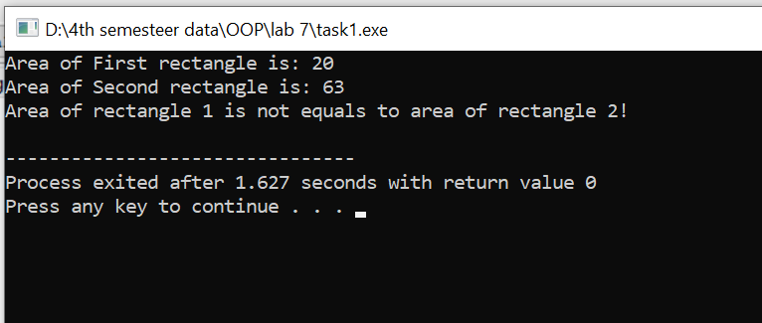

Task 2
Code:
#include <iostream>
using namespace std;
class Complex{
float real;
float imaginary;
public:
Complex(){
real=0;
imaginary=0;
}
Complex(float r,float i){
real=r;
imaginary=i;
}

Complex operator*(Complex &c){
Complex newObject;
newObject.real=(this->real*c.real)-(this->imaginary*c.imaginary);
newObject.imaginary=(this->real*c.imaginary)+(this->imaginary*c.real);

return newObject;
}

void display(){
cout<<this->real<<"+"<<this->imaginary<<"i"<<endl;
}
};
int main(){
Complex c1(5.0,6.0);
Complex c2(4.0,7.0);

cout<<"The First Complex Number is: ";
c1.display();
cout<<"The Second Complex Number is: ";
c2.display();
Complex c3=c1*c2;
cout<<"The third Complex Number is: ";
c3.display();

return 0;
}
OUTPUT:
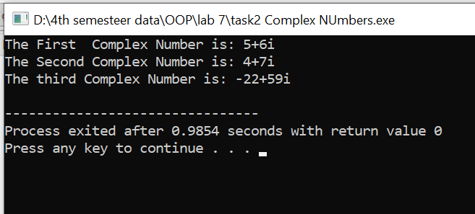
Task 3
Code:
#include <iostream>
using namespace std;
class Vector3D{
int x;
int y;
int z;
int magnitude;
public:
Vector3D(){
x=0;
y=0;
z=0;
}
Vector3D(int a,int b,int c){
x=a;
y=b;
z=c;

}
void Magnitude(){
magnitude=(x*x+y*y+z*z);
}
void Magnitude(int a,int b,int c){
magnitude=(a*a+b*b+c*c);
}
Vector3D operator+(Vector3D &v){
Vector3D resultant;
resultant.x=this->x+v.x;
resultant.y=this->y+v.y;
resultant.z=this->z+v.z;
resultant.magnitude=this->magnitude+v.magnitude;

return resultant;
}
bool operator==(Vector3D &v){
return magnitude==v.magnitude;
}

void display(){
cout<<"x = "<<x<<"| y = "<<y<<"| z = "<<z<<"| magnitude = the square root of ("<<magnitude<<")"<<endl;
}
};
int main(){
Vector3D v1(2,3,4);
Vector3D v2(5,3,2);
v1.Magnitude();
v2.Magnitude(6,7,4);
cout<<"-------------------------------------------vector #1\n"<<endl;
v1.display();
cout<<"\n-------------------------------------------vector #2\n"<<endl;
v2.display();

Vector3D v3=v1+v2;
cout<<"\n-------------------------------------------vector #3 before calculating its real magnitude\n"<<endl;
v3.display();

v3.Magnitude();
cout<<"\n-------------------------------------------vector #3 After calculating its real magnitude\n "<<endl;
v3.display();

if(v1==v2){
cout<<"\nvector 1 is equals to vector 2"<<endl;
}else{
cout<<"\nvector 1 is not equals to vector 2"<<endl;
}
return 0;
}
OUTPUT:
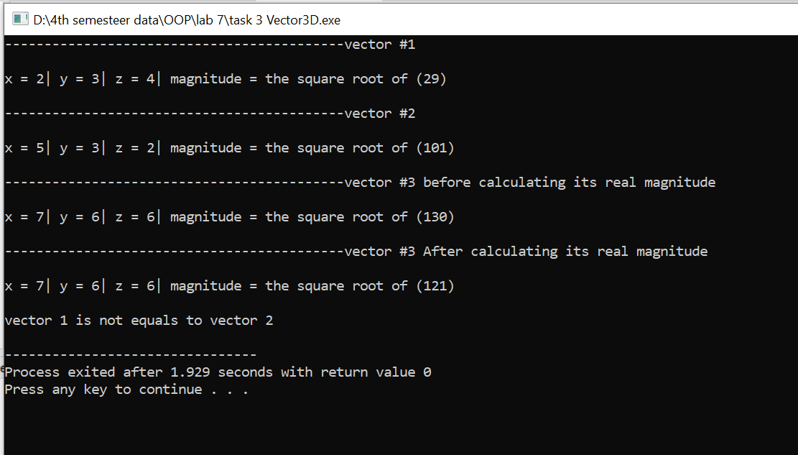

END,,,

